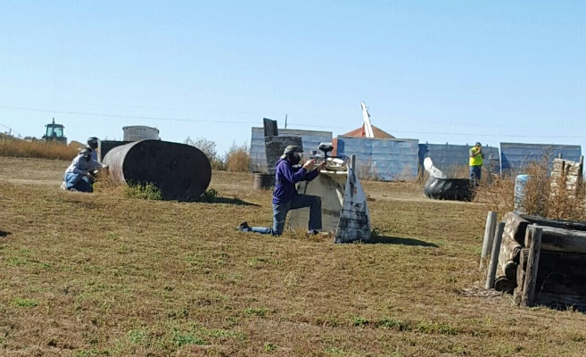
Shepherd’s Staff in rexford is having A… Paintball tournament!!
may 20, 2 pm
Meet us on Front St. at the Paintball field
HOW TO REGISTER
Register by completing the bottom portion of this form and returning it to: Shepherd’s Staff, Att. DJ and Laura Ter Haar, 325 Maple St., PO Box 56, Rexford, KS 67753 with your full payment of $40 per person Please make checks payable to Shepherd’s Staff Registrations are welcome up until the day of the competition
QUESTIONS? CALL OR TEXT LAURA TER HAAR AT 785-443-4601
Team Name: _____________________________________________
Team Captain: ___________________________________ Email: _____________________________________________
Phone # ________________________________________
Player 2: ________________________________________ Email: _____________________________________________
Player 3: ________________________________________ Email: _____________________________________________
Player 4: ________________________________________ Email: _____________________________________________
Player 5: ________________________________________ Email: _____________________________________________
Player 6: ________________________________________ Email: _____________________________________________
Player 7: ________________________________________ Email: _____________________________________________
Player 8: ________________________________________ Email: _____________________________________________
Player 9: ________________________________________ Email: _____________________________________________
Player 10: _______________________________________ Email: _____________________________________________

